# Lab 7

**Objectives:**

* To learn and understand how to design a multiple output combinational circuit using XOR and XNOR
* To learn and understand the working of different types of decoders
* To learn and understand how to design a multiple output combinational circuit using Decoders

**Exclusive-OR & Exclusive-NOR gates:**

The figure given below shows the symbol of Exclusive-OR (XOR) and Exclusive-NOR (XNOR) gates.

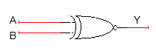 

XNOR gate XOR gate

Boolean expression of XNOR gate is $AB+ \overline{A}\overline{B}$ and Boolean expression of XOR is $\overline{A}B+A\overline{B}$. Boolean expression of XNOR gate can be implemented using XOR gate as shown in figure below:



**Function Table:**

|  |  |  |
| --- | --- | --- |
| **Inputs** | | **Output** |
| **A** | **B** | **Y** |
| L | L | L |
| L | H | H |
| H | L | H |
| H | H | L |

H= Logic High, L= Logic Low

**Connection Diagram:**

**74LS86 IC** will be used for implementation of XOR gate function. **74LS86 IC** contains four 2-input XOR gates. The function table and connection diagram for this IC are shown below:

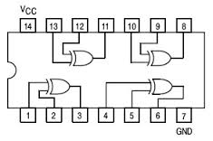

**2-to-4 line decoders:**

74LS139 IC contains two fully independent 2-to-4 line decoders with active low enables. The function table and connection diagram for this IC are shown below:

**Function Table:**

|  |  |  |  |  |  |  |
| --- | --- | --- | --- | --- | --- | --- |
| **Enable** | **Selection Inputs** | | **Outputs** | | | |
| **G** | **B** | **A** | **Y0** | **Y1** | **Y2** | **Y3** |
| H | X | X | H | H | H | H |
| L | L | L | L | H | H | H |
| L | L | H | H | L | H | H |
| L | H | L | H | H | L | H |
| L | H | H | H | H | H | L |

H= Logic High, L= Logic Low, X= Don’t Care

**Connection Diagram:**

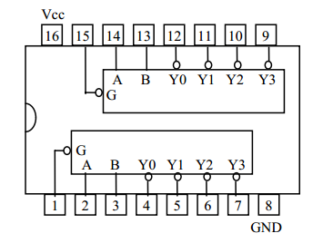

**3-to-8 line decoders:**

74LS138 IC contains 3-to-8 line decoder. The function table and connection diagram for this IC are shown below:

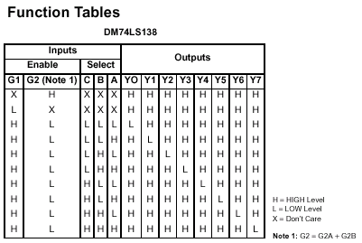

**Connection Diagram:**

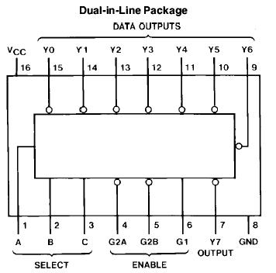

**Lab Tasks:**

**Question 1:**

Make a truth table and implement **2x4 Decoder with a low enable** using **8 AND gates and 3 NOT gates.**

**Question 2:**

Implement 3x8 decoder using two **2x4 decoders and NOT gate**

**Question 3:**

**4 bit parity Checker**

Implement a circuit that receives 4-bit message and outputs Error (E=1) if its parity is ODD

**(Implement it using XOR and XNOR gates)**